Humidity Detection System

PIC 1

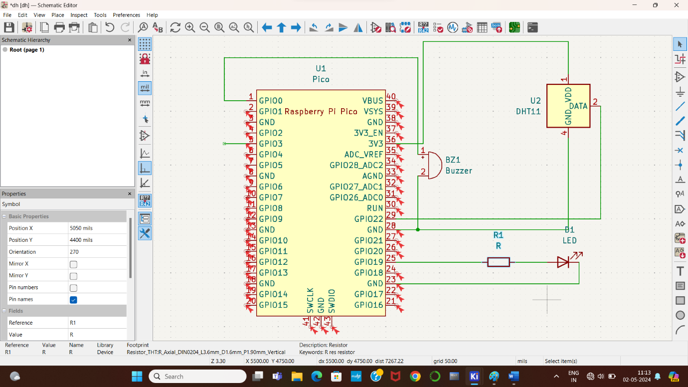

PIC 2

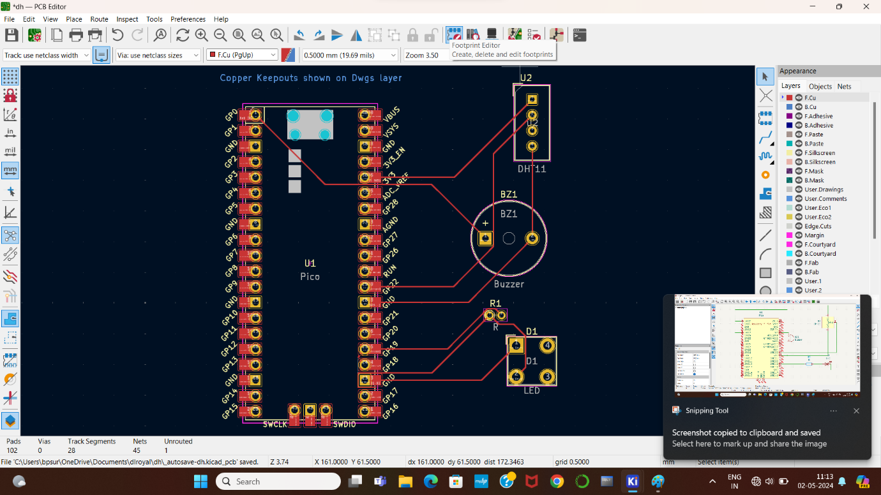

PIC 3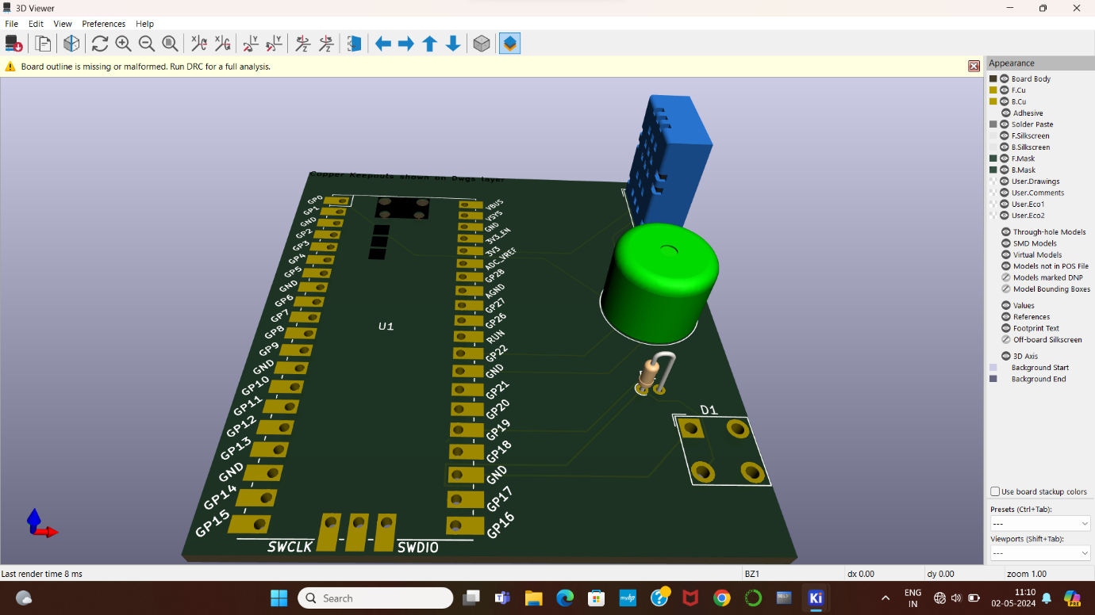

Roll No.

21781A04C7

21781A04E0

21781A04E8

21781A04F3

21781A04F4